[Certainly**C#** is an **object-oriented programming language** that enables developers to build a variety of secure and robust applications that run on the **.NET** framework1](https://dotnet.microsoft.com/en-us/learn/csharp).

Here are **five free resources** where you can learn C#:



1. **Microsoft’s Official C# Learning Center**: Offers free courses, tutorials, videos, and more to get you started with C# programming. [You can learn the basics, create your first “Hello World” application, and explore self-guided tutorials1](https://dotnet.microsoft.com/en-us/learn/csharp). [Learn C#](https://dotnet.microsoft.com/en-us/learn/csharp)
2. [**.NET Foundation’s Learning Resources**: Provides self-guided tutorials from Microsoft covering C# and .NET development for web, mobile, and more](https://dotnet.microsoft.com/en-us/learn/csharp)[2](https://dotnetfoundation.org/learn/education). [Learning Resources](https://dotnetfoundation.org/learn/education)

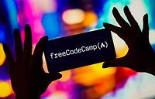



1. **FreeCodeCamp.org’s Full C# Course for Beginners**: This comprehensive course covers core concepts in C#, including installation, variables, data types, and more. [It’s a great starting point for beginners](https://dotnet.microsoft.com/en-us/learn/csharp)[3](https://www.freecodecamp.org/news/c-sharp-tutorial-for-beginners/). [Full C# Course](https://www.freecodecamp.org/news/c-sharp-tutorial-for-beginners/)

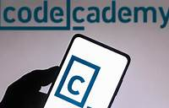

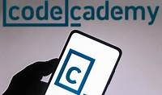

1. **Codecademy’s Learn C#**: Codecademy offers interactive lessons on C# topics such as “Hello World,” data types, logic, conditionals, and methods. [Perfect for beginners](https://dotnet.microsoft.com/en-us/learn/csharp)[4](https://www.codecademy.com/learn/learn-c-sharp). [Learn C# on Codecademy](https://www.codecademy.com/learn/learn-c-sharp)
2. **Microsoft Learn**: Explore Microsoft’s free tutorials and learning paths for C#. [Whether you’re a beginner or want to dive deeper into C# logic, Microsoft Learn has you covered1](https://dotnet.microsoft.com/en-us/learn/csharp)[5](https://dotnet.microsoft.com/en-us/learn). Here are some specific tutorials:
   * Take your first steps with C#
   * Add logic to your applications with C#
   * Work with data in C#

Happy learning! 🚀👩‍💻